Multiple-choice section

|  |  |  |  |  |  |  |  |  |
| --- | --- | --- | --- | --- | --- | --- | --- | --- |
| Question | 1 | 2 | 3 | 4 | 5 | 6 | 7 | 8 |
| Answer | C | B | D | A | D | C | B | C |

Question 1 [3.1]

C

 × 12 = 8 lollies

Question 2 [3.1]

B

 = 6 ÷ 2 = 3

Question 3 [3.1]

D

The smallest difference is between 1 and .

Question 4 [3.2]

A

HCF of 15 and 25 = 5

 = 

Question 5 [3.4]

D



= 

=  = 

Question 6 [3.3]

C

1 = , 2 =  and 3 =  so  is greater than 2, but less than 3.

Question 7 [3.5]

B

 of $35

= ** × **

= $7

Question 8 [3.6]

C

 ÷ 

=  × 

= 6

Multiple-choice total marks: 8

Short answer section

Question 9 2 marks [3.1]

(a) The *numerator* is the top number in a fraction, above the fraction bar.

(b) A *proper fraction* has a value less than one.

Question 10 1 mark [3.1]



Question 11 2 marks [3.2]

(a) (b)

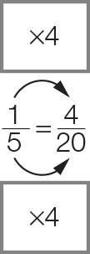 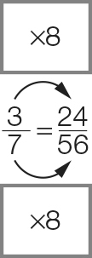

Question 12 8 marks [3.3]

|  |  |
| --- | --- |
| (a) (i) LCD = 30  (ii)  (iii) >  (iv) So > | (b) (i) LCD = 35  (ii)  (iii)  (iv) So  < |

Question 13 9 marks [3.4]

|  |  |  |
| --- | --- | --- |
| (a)   =  = | (b)   =  =  = | (c)   =  =  = |

Question 14 6 marks [3.5]

|  |  |  |
| --- | --- | --- |
| (a) of $30  =  = $20 | (b)  of   = | (c) |

Question 15 6 marks [3.6]

|  |  |  |
| --- | --- | --- |
| (a) 3 ÷  =  × = 12 | (b) ÷  =   = = | (c)  ÷ 5  = |

Short answer total: 34

Extended answer section

Question 16 5 marks [3.1, 3.2]

(a) (i)  (ii) 

(b) All fruit = 16 pieces  
  
=

(c) of all items = 16 ÷ 4 = 4  
16 – 4 = 12 items left

Question 17 9 marks [3.1, 3.2, 3.3]

(a)   
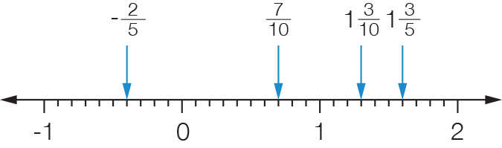

(b)    


(c) (i) 2 = 2 ×= 

(ii) 2 = 2 × = 

(d)  is between 1 and  with a difference of less than .  
is more than away.

(e) is the smallest as it is the only negative number.  
 is next as it is a proper fraction, followed by (), then  ( )

Extended answer total: 14

TOTAL test marks: 56